ST. XAVIER’S COLLEGE

**Maitighar,Kathmandu**

**(Affiliated to Tribhuvan University)**



**COMPUTER GRAPHICS**

**Lab Assignment #1**

**Submitted By**

Ajita Khatiwada

B.Sc. CSIT

Year II/IV Semester

013BSCIT004

**Submitted To**

Er. Anil Kumar Shah

Lecturer,

Department of Computer Science

St. Xavier’s College

Maitighar, Kathmandu

**Submitted On**

August 4, 2015

**STATEMENT: “ TO DRAW THE FOLLOWING CHECKBOX”**

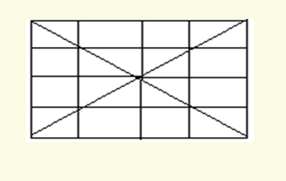

**PROGRAM CODE:**

//---------------------------------------------------------------------------

#include <vcl\vcl.h>

#pragma hdrstop

#include "line2.h"

//---------------------------------------------------------------------------

#pragma resource "*.dfm"

TForm1 *Form1;

//---------------------------------------------------------------------------

__fastcall TForm1::TForm1(TComponent* Owner)

: TForm(Owner)

{

}

//---------------------------------------------------------------------------

void __fastcall TForm1::Button1Click(TObject *Sender)

{

Form1->Canvas->MoveTo(10,10);

Form1->Canvas->LineTo(200,200);

Form1->Canvas->MoveTo(10,10);

Form1->Canvas->LineTo(10,200);

Form1->Canvas->MoveTo(10,10);

Form1->Canvas->LineTo(200,10);

Form1->Canvas->MoveTo(10,200);

Form1->Canvas->LineTo(200,200);

Form1->Canvas->MoveTo(10,200);

Form1->Canvas->LineTo(200,10);

Form1->Canvas->MoveTo(200,10);

Form1->Canvas->LineTo(200,200);

Form1->Canvas->MoveTo(55,10);

Form1->Canvas->LineTo(55,200);

Form1->Canvas->MoveTo(105,10);

Form1->Canvas->LineTo(105,200);

Form1->Canvas->MoveTo(155,10);

Form1->Canvas->LineTo(155,200);

Form1->Canvas->MoveTo(10,55);

Form1->Canvas->LineTo(200,55);

Form1->Canvas->MoveTo(10,105);

Form1->Canvas->LineTo(200,105);

Form1->Canvas->MoveTo(10,105);

Form1->Canvas->LineTo(200,155);

}

//---------------------------------------------------------------------

**OUTPUT:**

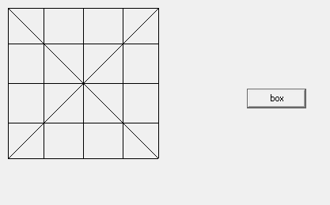

**CONCLUSION:**

Hence, the above checkbox was drawn using the LineTo and MoveTO functions in C++ Builder.